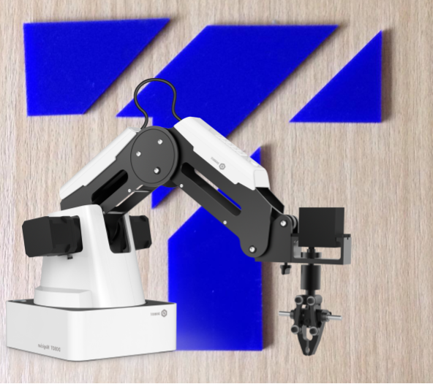

## 

|  |
| --- |
| [Sensors and Control - Dobot Magician Solving T-Puzzle]  [Project 3 - Control grasping for the Dobot Magician Robot]  [22/10/2018]  James Walsh (99143152) 50%  Jordan Henry (97117446) 50% |

**Contents**

Project Proposal 3

Aim 3

Tasks included 3

Methodology 4

Task 1 Moving the Dobot Magician arm 4

Task 2 Using the camera 4

Task 2.1 Getting information from the camera 4

Task 2.2 Calibrating the camera 5

Task 3 Using camera images to find the positions of shapes and their centroids 5

Task 4 Using images to find pose of centroids from camera 6

Task 5 Using images to find the orientations of the pieces 7

Task 6 Moving the arm into given pose to generate T puzzle 7

Challenges 7

Calibration of the camera 7

Stereo images 7

Incorrect Depth values 8

Inverse kinematics of a Robotic Manipulator with Mechanical Links 8

Outcome 8

References 9

Appendix 10

# Project Proposal

## Aim

Our groups aim is the program the Dobot Magician arm to complete the 4 piece T-puzzle from any starting position into the final T shape as phone in figure_1

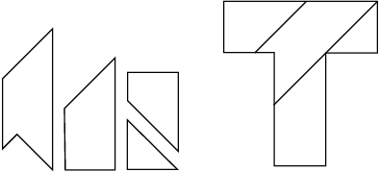

**Figure 1: T puzzle example pieces and solution**

## Tasks included

We undertook Project 3 - Control grasping for the Dobot Magician Robot by using the requirements of Project 4 - Hand-eye calibration for the Dobot Magician Robot. This was done by using the Intel Realsense r200 RGBD camera in order to use sensing to locate and thus grasp the T-Puzzle pieces and fulfil the requirements of Project 3.

Task 1 Moving the Dobot Magician arm

Task 2 Using the camera

Task 3 Using camera images to find the position of the centroids

Task 4 Using images to find pose of centroids from camera

Task 5 Using images to find the orientations of the pieces

Task 6 Moving the arm into given pose to generate T puzzle

# Methodology

## Task 1 Moving the Dobot Magician arm

To begin to move the Dobot Magician Arm we needed to get our hands on a physical Dobot Magician and measure the lengths of each of the joints so that the endefector position could be calculated by using inverse kinematics.

As the end effector of the Dobot Magician is always pointed vertically down, this was the ideal robotic manipulator for the proposed task as it provides a guaranteed certainty that the end effector or suction cup gripper was always going to be perpendicular to our t puzzle pieces thus that one we have moved the robotic arm onto the piece it is going to pick up that piece every time. This would be unlike some other collaborative robotic manipulators that could have slight error in the joint angles and thus the suction cup gripper could have a slight tilt allowing air to penetrate between the suction cup gripper and the surface to be gripped.

The Dobot Magician also had its limitations where it only has a very small workspace, thus in the UTS subject robotics we have used a turtlebot as the Dobot Magicians mobile base increasing the working area by an infinite amount between two horizontal planes that define the highest and lowest reach of the Dobot Magician. For this project we just ensured that the puzzle pieces were within the robots reach and vision as adding the Dobot Magician to the project would add a large challenge to the task which would not be possible due to the time limitations enforced from the 12 week university semester which we had to complete the task and our current lack of knowledge and practice in areas such as ROS, SLAM and Collision Avoidance.

## Task 2 Using the camera

### Task 2.1 Getting information from the camera

using the camera was done through using a ROS subscriber receiving a message from the intel joule, this message was the information matrix for the image and was then able to be stored and saved within matlab for further processing.

Below is an example of how we got images from the camera to take the 100 photos used for calibration

close all

clear all

clf

clc

try rosshutdown;end

ipaddress = '192.168.31.141';

rosinit(ipaddress)

for i = 1:100

imageSub = rossubscriber('/camera/color/image_raw');

pause(1);

image = readImage(imageSub.LatestMessage);

filename = num2str(i);

filename = strcat(filename,'.jpg')

imwrite(image, filename);

pause(3);

end

### Task 2.2 Calibrating the camera

Using the camera calibration toolbox for matlab, the principal point and focal length of the intel realsense r200 camera that was loaned to our group for the project. This was done by printing out and example chess board. Then taping it to a flat piece of wood to make sure it didn’t crease in the photos. After this 100 images were taken and captured for later processing, which of about 20 had to be deleted because of blur or being out of screen. The second most outer corners were used to calibrate to be able to use the most amount of data that we could, and therefore get the most accurate calibration. With our final result being

Focal Length:

fc = [ 617.71357 621.46770 ] %+/- [ 2.12317 2.13763 ]

Principal point:

cc = [ 304.46207 212.39134 ] %+/- [ 2.72962 2.89598 ]

## Task 3 Using camera images to find the positions of shapes and their centroids

Initially when looking into this problem I knew that having a high colour contrast from the objects that we were interested in and their surroundings would ensure that the data received from the camera had more accuracy and it would make the image easier to process. The Image taken had a white background and a solid blue colour of the shapes, thus by just looking at the regions of the image that showed more blue we were able to quickly generate a black and white image with the white regions being the puzzle pieces and the black regions being the background.

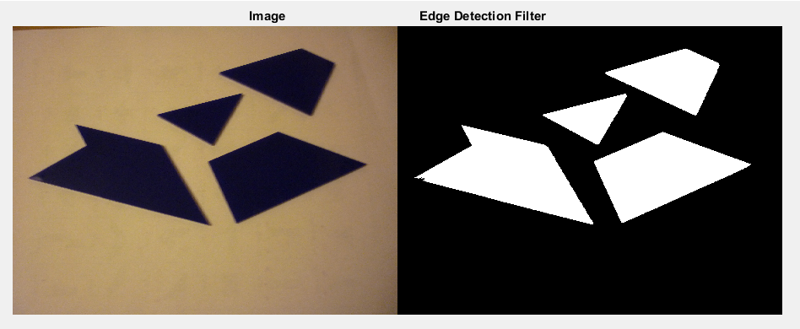

Then we were able to look at the area of the white regions to identify the shapes with the largest white area being shape 1 the second largest area being shape 2 and so on. Once we had 4 black and white images with one of the shapes on each image we were able to find the centroid of all of the white pixels on that image and this is where the end effector need to travel to in order to pick up the T-Puzzle Piece.

Instead of using Shape detection we were also considering using edge detection or corner detection which we believed could have made the method of finding the orientation of the puzzle pieces easier one we could identify points along the edges of the shapes, we would need to determine the groups of points that belonged to each of the edges. With this information we would have either been able to draw a line of best fit along that edge or just taken the corners and once this methodology was performed with each edge we would then need to identify what edges or corners would form groups to make up each shape. We could then easily look at the perimeters of the shapes and identify the shapes based on shape 1 having the largest perimeter and shape 2 having the second largest perimeter and so on, alternatively we could use enclosed area. The number of corners or edges for each shape could then be used to further test that the correct shape had been identified. Then by looking at the longest edge and its orientation it would have been simple to identify the orientation of each piece and then calculate the rotation that needed to take place.

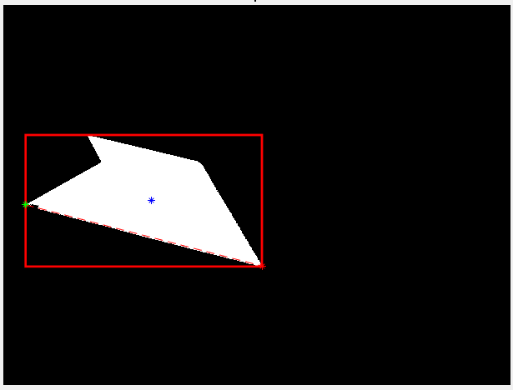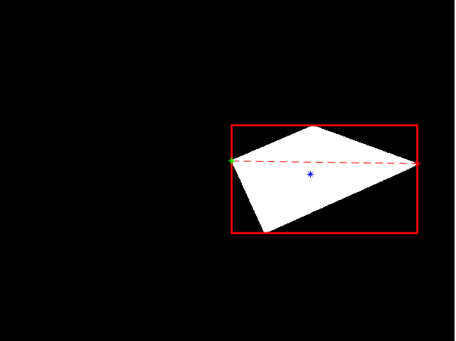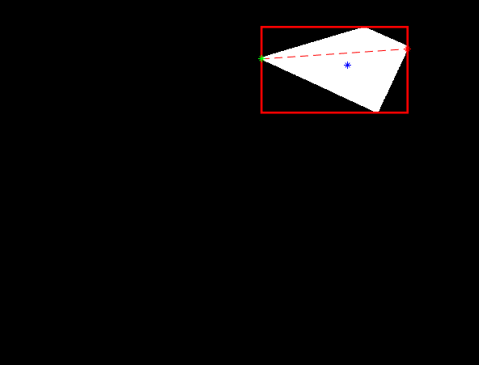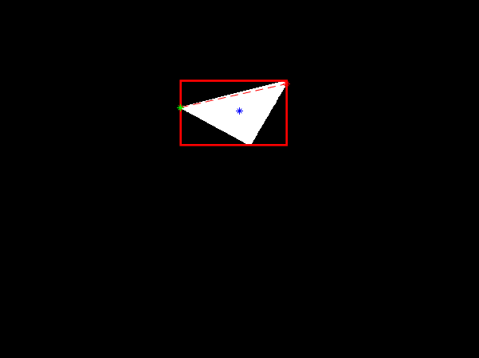

## Task 4 Using images to find pose of centroids from camera

To find the pose of the centroid of a shape that was going to be moved by the Dobot Magician arm, there had to be two images stored with the relative camera position of each recorded to find the change in distance between the two cameras when taking the photo.

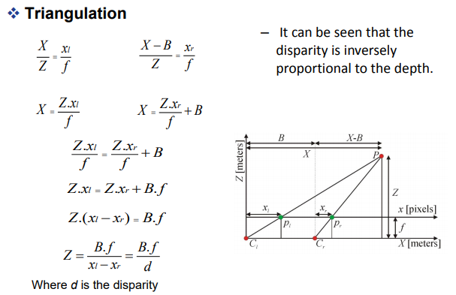

This information along with the two portions of the centroids on the image, with the two values for focal length and principle point. At this point we can now use triangulation to find the X, Y, and Z distances of the point we choose away from the camera. This can now be used to create a pose of the ender factor to the centroid of the desired shape

## Task 5 Using images to find the orientations of the pieces

To find the orientation of the pieces we would look at the 4 black and white images which all have one shape each and find the two white pixels that were separated by the longest distance, this line between the two pixels then became our reference line. Thus all we needed to do is to calculate the angle between where the reference line was and where we needed the reference line to be to find the angle of required rotation.

## Task 6 Moving the arm into given pose to generate T puzzle

The Location that the pieces needed to be placed was all calculated by hand and then the positions that the end effector needed to be moved to were measured by rulers off the scaled model drawing. This allowed the final positions to be accurate and set at a constant location. Then Inverse kinematics was used to find the joint angles which were sent to the Dobot Magician via a ROS Service. We did initially try and use the cartesian ROS service to move the Dobot Magician arm but we soon realised that this was not very accurate and seemed to have an even further reduced range of motion. Thus resulting in finding the joint angles with inverse kinematics.

When using the Dobot Magician as there is only a +/- 135 degree of rotation on the end effector in order to rotate a piece in the extreme condition that it needed to be rotated over the 135 degrees the end effector would need to be rotated to a maximum of 45 degrees in the opposite direction so that this rotation would be possible. Thus careful planning needed to take place in order to get this right without falling into further pithole and having further issues with the project.

# Challenges

## Calibration of the camera

When calibrating the testing cameras and taking photos through a third party app to then manually process it and test if the calibration was finding correct focal lengths to find the pose of the shapes, it was found that the third party software would change the focus of the image sometimes cause very inaccurate values for the focal length calculated by the tool box making it very difficult to set up testing for the triangulation section of the code and assess it as its own block of code. This was fixed by going into the settings and disabling it after realising the issue, and was also a non issue once the camera images were processed through ROS from the intel realsense camera

## Stereo images

When taking the two photos for later processing the triangulation was first set up to use a change in x of the arm to be the disparity, however in practice it was found to achieve this change in pose cause the arm to move to a different angle and would therefore cause the software to be unpredictable with no consistency between attempts. To fix this instead of taking photos left and right, the photos were taking up and down along the y axis this allowed the camera to remain at a consistent angle throughout the process and therefore leaded to much more consistent numbers.

## Incorrect Depth values

When accessing for the depth from the camera it was sometimes found that the Z value would either be to great or too small this is a major issue as if it was to great would cause the next actions to be off as the arm seemed to forget which pose it was located in and if it was too small had no chance of picking up a T puzzle piece regardless of the XY accuracy, so in order to make sure the Dobot Magician picked up the shapes more consistently, the pose was found between the starting position and the base where the shapes were places and was calculated through the change in joint angles to allow for the ender effecter to always be the correct Z value to pick up the piece even if the XY aren’t completely accurate.

## Inverse kinematics of a Robotic Manipulator with Mechanical Links

This was difficult as it is more than just considering the joint angles as we then have to consider what is the relationship between joint angles based on the mechanical links. Thus making the inverse kinematics to determine the position of the joint angles in order to get the robotic arm manipulation to move its end effector to the desired position in the desired pose if more that one pose exists.

**Robot Approaching its Joint limits**

As the robotic Manipulator approached its joint limits it would no longer be accurate with its joint angles due to some of the joints freezing up this was later found to be a issue with the hardware and not the code. Therefore we just made modifications to where the T-Puzzle pieces were located and needed to be placed in order to avoid the end effector colliding with its environment. This movement of the pieces can be seen by the final orientation of the T puzzle being slightly off alignment as the angles of the pieces were calculated when the T Puzzle was directly alongside the Dobot Magician. These angle of rotation values were hard coded into the code as being the end orientations of the T puzzle pieces so due to the puzzle being shifted forward the angles in the code was not changed due to lack of time left to complete the task.

# Outcome

The Project was mostly successful except having accuracy issues with determining the orientation of the shapes, Thus for the project/demonstration we changed the task so that the shapes could be placed anywhere in the Camera’s and Dobot Magician’s range but always oriented the same way so that we were only relying to the camera image and the image processing code to find the location of the centroid of the shape to be picked up.

If we had more time to complete the project Instead of translating the end effector in one movement and taking another movement to rotate the end effector I would just do both of these steps together.

To make the selection and pick of the pieces more accurate we would look into how we could incorporate visual servoing and the use of Quick Response (QR) or Augmented Reality (AR) Codes. This would make the orientation task easier but in such real life application it may not be practical to attach these codes to the objects which you would like your robotic manipulator to pick and place

# References

* <https://www.printingimages.com/pi-news-articles-comment021315.html>
* <https://www.robotlab.com/store/dobot-robotic-arm>
* <https://ark.intel.com/products/92256/Intel-RealSense-Camera-R200>

# Appendix

